Java 8 Features

Lambda Expressions

Functional Interfaces (java.util.function)

Method References

Stream API

Parallel Streams

Collectors API

Default Methods in Interfaces

Static Methods in Interfaces

Optional Class ( Introduced to avoid NullPointer Exception )

New Date and Time API (java.time package)

CompletableFuture API

forEach() method in Iterable

Base64 Encoding and Decoding API

Nashorn JavaScript Engine

Type Annotations

Repeating Annotations

1. List down the new features introduced in Java8?
New features that are introduced in Java 8 are enlisted below:
• Lambda Expressions
• Method References
• Optional Class
• Functional Interface
• Default methods
• Nashorn, JavaScript Engine
• Stream API
• Date API
• String Joiner class

2. What are Functional Interfaces?
A functional interface is an interface that contains exactly one abstract method and can be implemented using a lambda expression.
It can have:
- ✅ One abstract method
- ✅ Any number of default methods
- ✅ Any number of static methods
But only one abstract method.
sayHello() is the single abstract method.
We implement it using a lambda expression.
@FunctionalInterface
interface MyFunctionalInterface {
void sayHello(); // Only ONE abstract method
}
public class Test {
public static void main(String[] args) {
MyFunctionalInterface obj = () ->
System.out.println("Hello Akash");
obj.sayHello();
}
}

@FunctionalInterface
interface FunInterface{
public int multiply(int a ,int b);
}
public class Test{
public static void main(String args[]){
FunInterface obj=(a,b) -> a*b;
System.out.println(obj.multiply(30,20));

@FunctionalInterface is optional annotation. It tells the compiler:
- This interface must contain only one abstract method
- If you add another abstract method → compile-time error
Note:
Runnable and callable are few examples of functional interfaces.
Functional Interfaces are also called as SAM interfaces.
Difference between Functional Interface and normal Interface
A functional interface is a special type of interface that contains exactly one abstract method and is used to support lambda expressions.
Whereas a normal interface can contain multiple abstract methods and is used for traditional abstraction in OOP and cannot be used for lambda expression as compiler won’t be able to know which function it has to call.
interface MyNormal {
void method1();
void method2(); // Multiple abstract methods allowed
}

MyNormal obj = () -> System.out.println("Hello"); // ❌ Error

3. What are some of the functional interfaces?
- Predicate
- Consumer
- Supplier
- Function

4. What is an optional class?

Optional class is a special wrapper class introduced in Java 8 which is used to avoid NullPointerExceptions. This final class is present under java.util package.

5. What is a Default Method?
Default methods are the methods of the Interface which has a body. These methods, as the name suggests, use the default keywords. The use of these default methods is “Backward Compatibility” which means if JDK modifies any Interface (without default method) then the classes which implement this Interface will break. On the other hand, if you add the default method in an Interface then you will be able to provide the default implementation. This won’t affect the implementing classes.
public interface questions {
default void print() {
System.out.println("www.softwaretestinghelp.com");
} }

6. What was wrong with old date and time?
• Java.util.Date is mutable and is not thread-safe whereas the new Java 8 Date and Time API are thread-safe.
• Java 8 Date and Time API meets the ISO standards whereas the old date and time were poorly designed.
• It has introduced several API classes for a date like LocalDate, LocalTime, LocalDateTime, etc.
• Talking about the performance between the two, Java 8 works faster than the old regime of date and time.

7. What are the method references?
Method reference is a short-hand notation of lambda expression to call the method directly.

If the Lambda Expression looks like num -> System.out.println(num)
Then the corresponding Method Reference would be, System.out::println
It is a static method reference to println method of out object of System class.

String:: Valueof Expression: It is a static method reference to the ValueOf method of the String class
// Real Stream Example
List<String> list = Arrays.asList("A", "B", "C");
list.stream()
.map(String::toLowerCase)
.forEach(System.out::println);

8. What is predicate? State the difference between predicate and function
Predicate is a pre-defined Functional Interface. It is under java.util.function.Predicate package. It accepts only a single argument which is in the form as shown below,
Predicate<T>
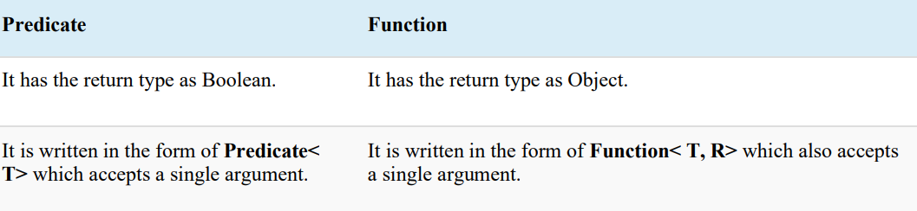

9.What are the main characteristics of the lambda expression?
Lambda expression was introduced in java 1.8 to enable Functional Programming.
Lambda is an anonymous function with no name, no modifier and no return type
A method that is defined as Lambda Expression can be passed as a parameter to another method.
• A method can exist standalone without belonging to a class.
• There is no need to declare the parameter type because the compiler can fetch the type from the parameter’s value.
• We can use parentheses when using multiple parameters but there is no need to have parenthesis when we use a single parameter.
• If the body of expression has a single statement then there is no need to include curly braces.

10. Can a functional interface extend/inherit another interface?
Yes, a functional interface can extend another interface — but with one strict condition: After inheritance, the total number of abstract methods must still be exactly ONE.

11. What is SAM interface?
Functional Interfaces are an interface with only one abstract method. Due to which it is also known as the Single Abstract Method (SAM) interface.

12. What are the various categories of pre-defined function interfaces?
1) Function: To transform arguments in returnable value.
Used for mapping / transformation -> map() in stream
Example: String → Integer, User → DTO, etc.
import java.util.function.Function;
public class FunctionExample {
public static void main(String[] args) {
Function<String, Integer> lengthFunction = s -> s.length();
int length = lengthFunction.apply("Akash");
System.out.println(length); // 5
}
}

2) Predicate: To perform a test and return a Boolean value.
Used for filtering -> Filter method in streams
import java.util.function.Predicate;
public class PredicateExample {
public static void main(String[] args) {
Predicate<Integer> isEven = num -> num % 2 == 0;
System.out.println(isEven.test(10)); // true
System.out.println(isEven.test(7)); // false
}
}

3) Consumer: Accept arguments but do not return any values.
Used for side effects
Example: printing, saving to DB, logging, etc.
import java.util.function.Consumer;
public class ConsumerExample {
public static void main(String[] args) {
Consumer<String> printName = name ->
System.out.println("Hello " + name);
printName.accept("Akash");
}
}

4) Supplier: Do not accept any arguments but return a value.
import java.util.function.Supplier;
public class SupplierExample {
public static void main(String[] args) {
Supplier<Double> randomValue = () -> Math.random();
System.out.println(randomValue.get());
}
}

Operator: Special type of Function where input and output types are same.
import java.util.function.UnaryOperator;
public class UnaryOperatorExample {
public static void main(String[] args) {
UnaryOperator<Integer> square = num -> num * num;
System.out.println(square.apply(5)); // 25
}
}

13. What are some standard Java pre-defined functional interfaces before Java 8?
Some of the famous pre-defined functional interfaces from previous Java versions are Runnable, Callable, Comparator, and Comparable. While Java 8 introduces functional interfaces like Supplier, Consumer, Predicate, etc
1. Runnable: use to execute the instances of a class over another thread with no arguments and no return value.
2. Callable: use to execute the instances of a class over another thread with no arguments and it either returns a value or throws an exception.
3. Comparator: use to sort different objects in a user-defined order
4. Comparable: use to sort objects in the natural sort order
14)What is STREAM API?
Stream API is a new feature added in Java 8. It is a special class that is used for processing objects from a source such as Collection.

15)What is the difference between skip and limit?
The limit() method is used to return the Stream of the specified size. For Example, If you have mentioned limit(5), then the number of output elements would be 5.
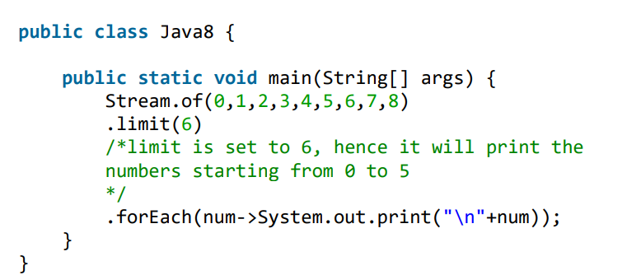
Whereas, the skip() method is used to skip the element.
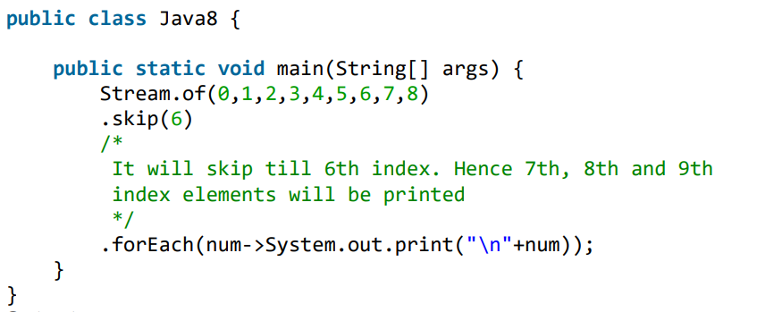

16)What is the difference between findFirst() and findAny()?
As the name suggests, the findFirst() method is used to find the first element from the stream whereas the findAny() method is used to find any element from the stream.

17) What is Nashorn in Java 8?
Nashorn in Java 8 is a Java-based engine for executing and evaluating JavaScript code

18)What is the difference between Intermediate/ Non-Terminal and terminal operations in stream?
Intermediate/Non – Terminal operations are those which convert a stream into another stream.
Terminal operations are the one which produce a result and end the pipeline
Non-Terminal Operations
------------------------
filter()
map()
distinct()
sorted()
peek()

Terminal Operations
--------------------
anyMatch()
collect()
count()
findFirst()
min()
max()
sum()
average()

methods
---------------------
reduce() -> to do series of transformation

18)Difference between map and flatMap?
Map | FlatMap
This operation gives one output value per input value. | This operation gives zero or more output values per input value.
One-to one mapping occurs in map() | One to many mapping occurs in flatMap().
Produces a stream of values | Produces stream of stream values
It is used only for transformation | It is used for both transformation and mapping

19)Explain StringJoiner Class in Java 8? How can we achieve joining multiple Strings using StringJoiner Class?
By using StringJoiner we can join multiple strings separated by delimiter along with providing prefix and suffix to them.
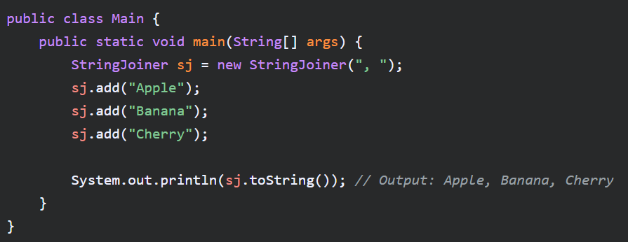
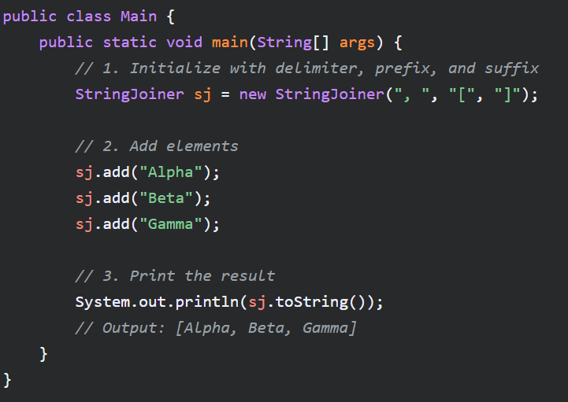

20)What is the difference between collection and stream?
Collections are group of objects and java provides us collection framework to store, access, update and manage data accordingly.
Stream is a pipeline for processing them. It provides complex operations like filtering, mapping, reducing etc.

21)Why streams are lazy?
Streams are lazy to optimize performance by only executing intermediate operations (like filter or map) when a terminal operation (like collect or forEach) requires a result. This approach avoids unnecessary computations, enables processing of large or infinite datasets, and chains operations together to process data in a single pass.

22)What are parallel streams?
Java Parallel Streams is a feature of Java 8 and higher, meant for utilizing multiple cores of the processor.
Normally any Java code has one stream of processing, where it is executed sequentially. Whereas by using parallel streams, we can divide the code into multiple streams that are executed in parallel on separate cores and the final result is the combination of the individual outcomes. The order of execution, however, is not under our control.
When to use?
Parallel streams are best used when the order doesn’t matter, elements don’t depend on each other, and data remains unchanged.

Sequential Streams and Parallel Streams
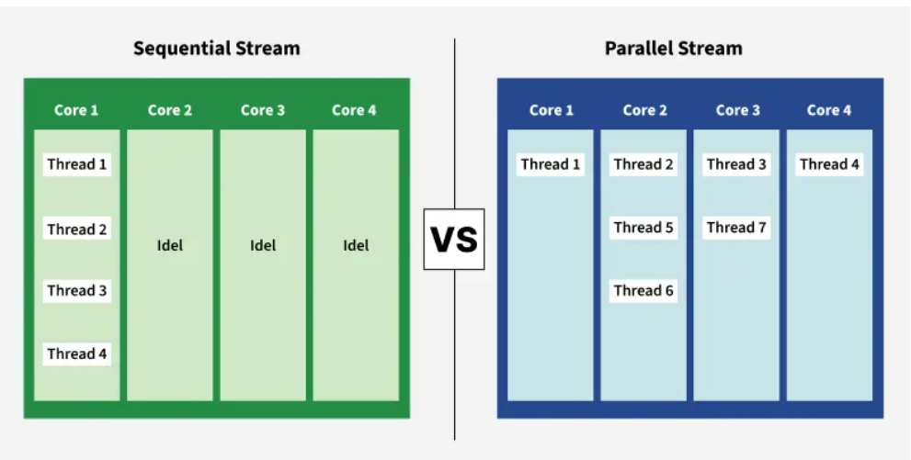

- Sequential Streams: Process elements in a sequential manner, one element at a time
- Parallel Streams: Process elements in parallel, utilizing multiple CPU cores.

How to Create and Use Parallel Streams
There are two main ways to create parallel streams in Java:
a) using parallel() method
b) using parallelStream() method

